Discord Passcode: https://discord.gg/TJeGkq

Cutesy

City of cute blob creature things are invaded by aliens. The alien’s mothership drops cages that traps the populace. A lone hero use their power to ram into others and transmit their *Force* to *Break* their friends free.

Stage 1:

**World**: Nice City, green parks, clean cement, newly painted road and parking lot lines.



**Walls**: Bricks

**Objective**: Escape by break the wall

**Handicap**: None

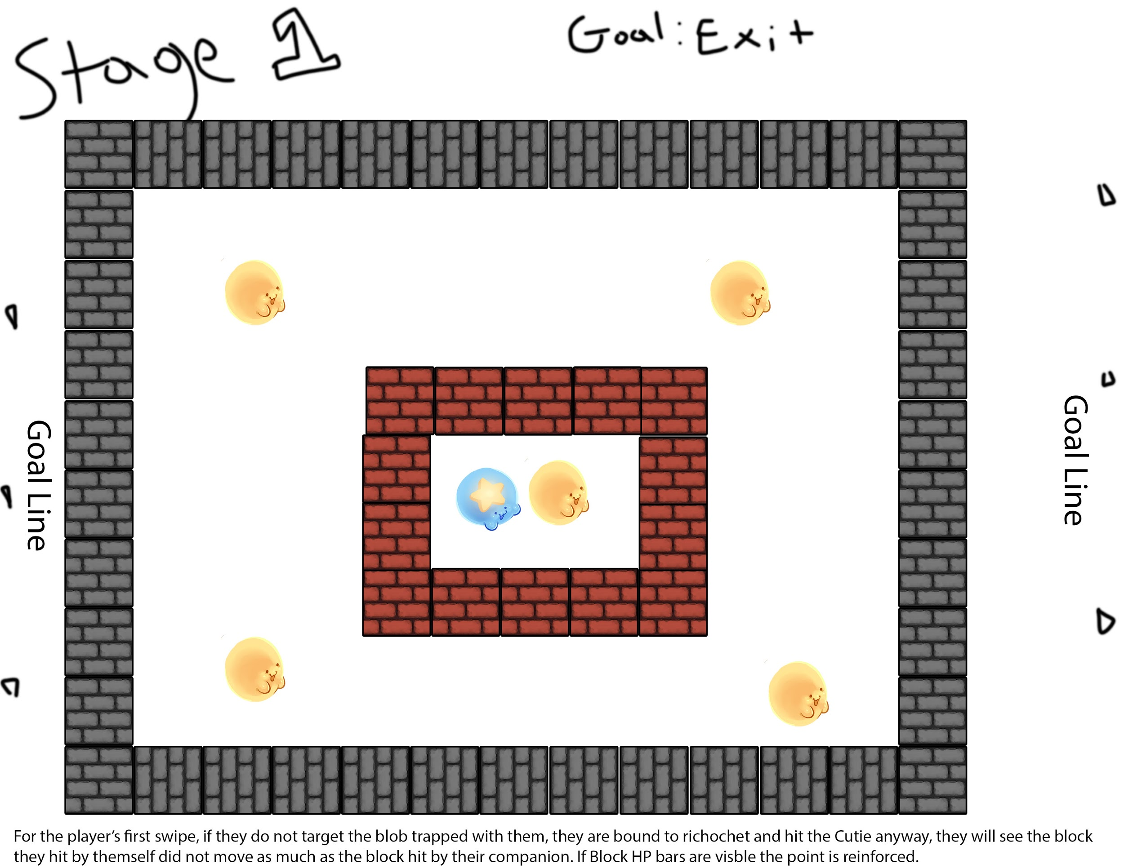

Level Design: Player is separated from another bubble by a wall. The wall is easily broken, allowing the user to hit the other ball and shatter the outer wall. This will teach the players the fundamentals of the game, such as dragging and shooting, and that if they hit another ball, the other ball will speed up on hit.

After breaking free the invaders move their attention over to the candyland forest next door. The horde of blobs chasing their invaders get distracted and start eating the candy around them. The invaders drop another cage on the Cuties, but most don’t mind. The Star Cutie notices their predicament and does their best to free everyone.

Stage 2:

**World**: Pink Candyland area. Cotton candy

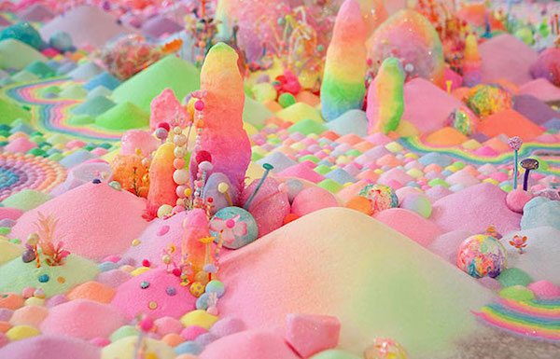

**Walls**: Candy Cane

**Objective:** Escape by breaking the wall

**Handicap:** None

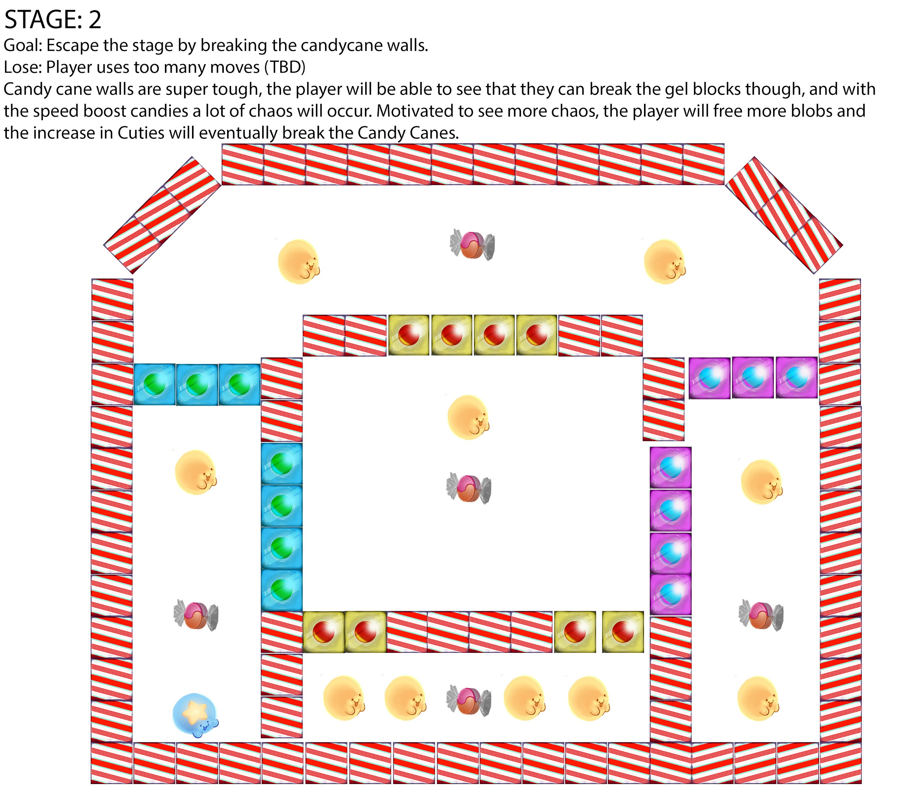

The Cuties follow the aliens into an industrial zone. There they are ambushed by a meaner looking alien ship that drops a cage made of solid concrete/steel. No matter how much *Force* is transmitted, the Cuties do not make a dent in their prison. One Cutie notices they are trapped with TnT, which the Cuties use for fun and recreation as they can not be injured by explosions.

Stage 3:

**World**: Industrial zone, Factory Floor, Moving parts, Machinery. Fire if you want.  
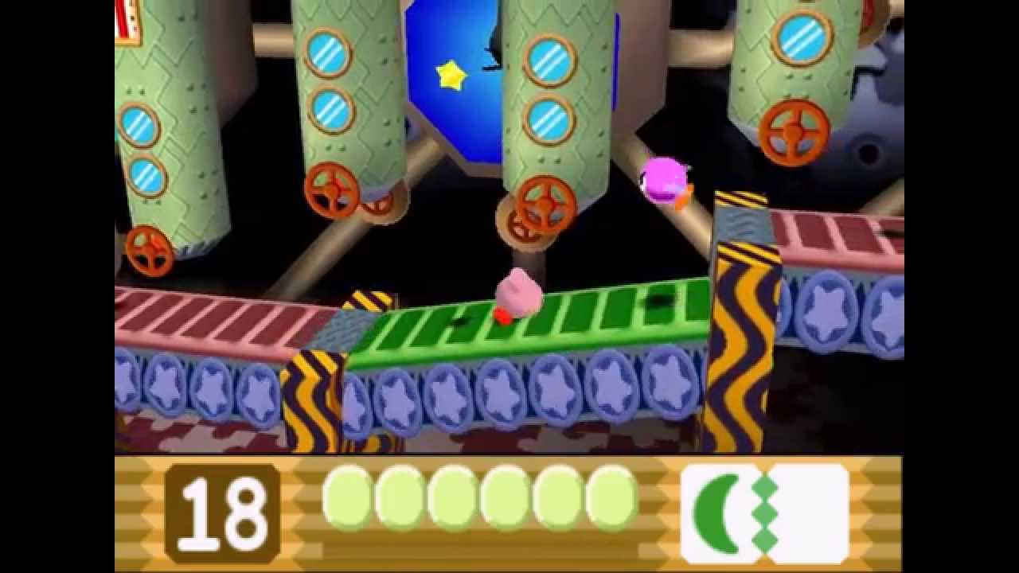

**Walls**: Concrete/Steel

**Objective**: Use TnT to break walls

**Handicap**: Walls can only be broken by collision.

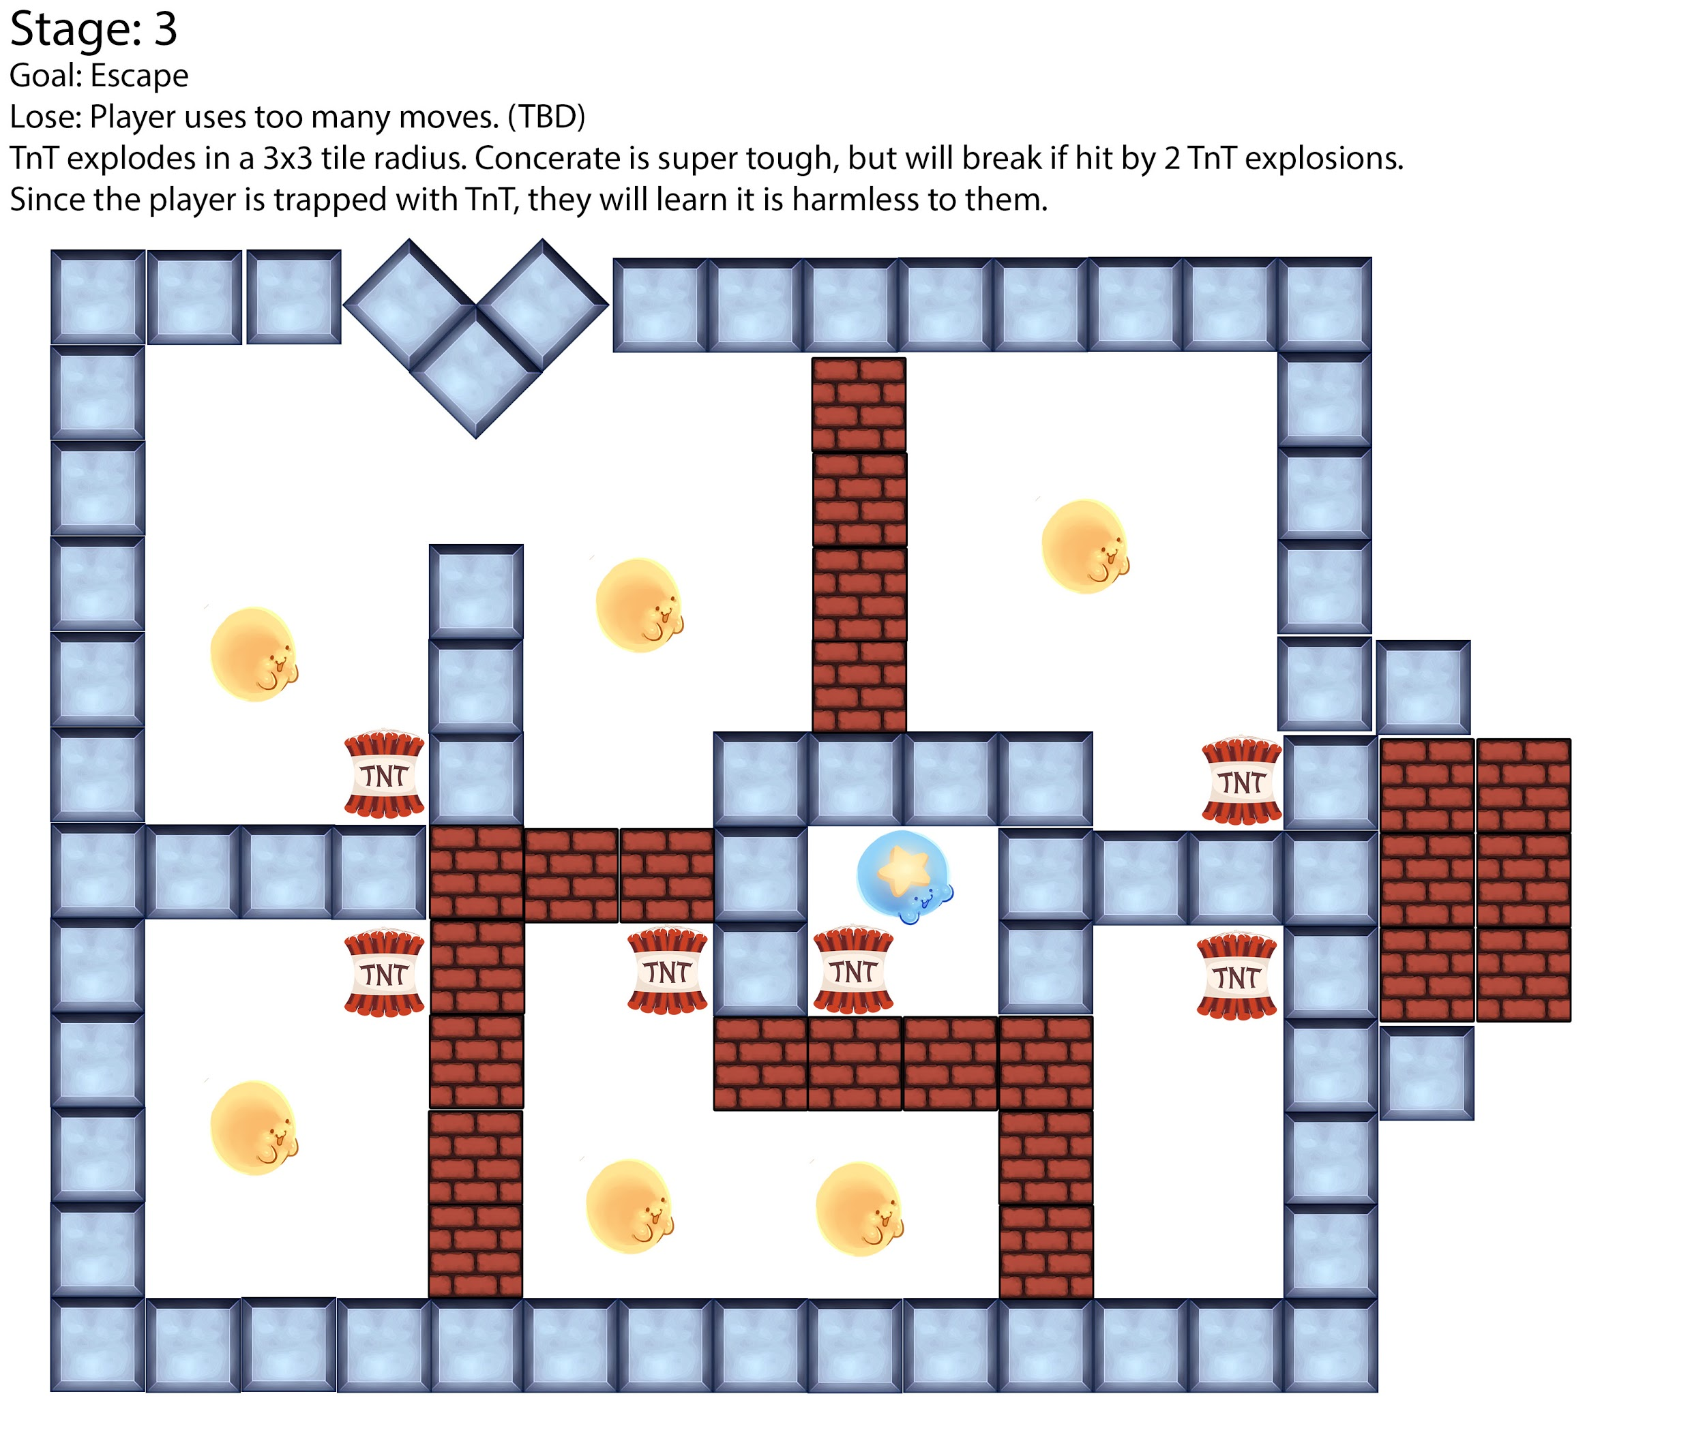

The Cuties continue on their way up a grand mountain that leads to the land in the sky. They plan to drop on the alien ships from above. At the mountains peak an alien device stands guard. It visible weak point can be seen moving on its body.

Stage 4:

**World**: Skyworld, either have a mountaintop or aretchture from that stage from Smash Brothers:

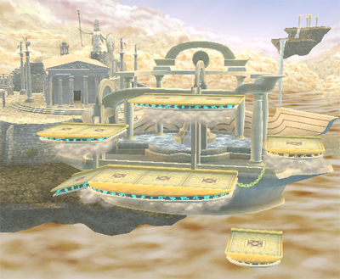

**Walls**: Greek/Roman Columns.

**Objective**: Defeat the boss

**Handicap:** Boss’s weapoint moves / May require a Cutie to be hit by TnT, then hit the weak point to count as damage.

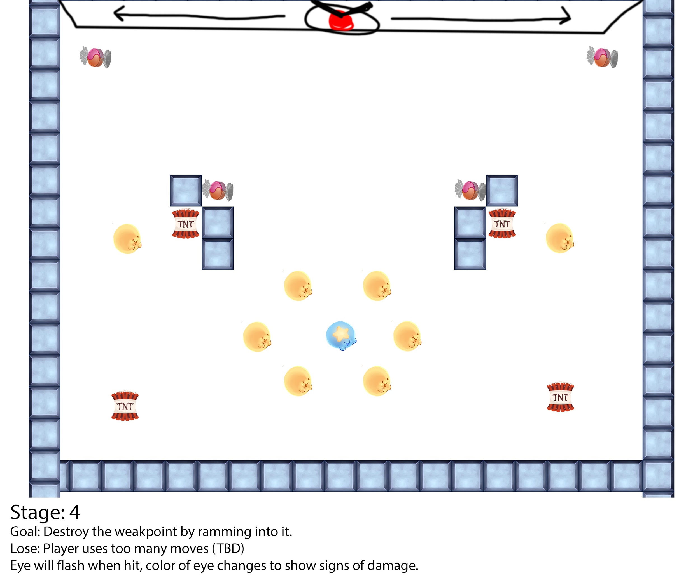

The Cuties defeat the mean looking alien ship and infiltrate the mothership from above. Inside the find a glowing green cylinder. Believing the brightly colored object to be the weak point, the Cuties make their final assault to bring down the mothership.

Stage 5:

**World**: Inside a spaceship. Futuristic, neon. Alienware.

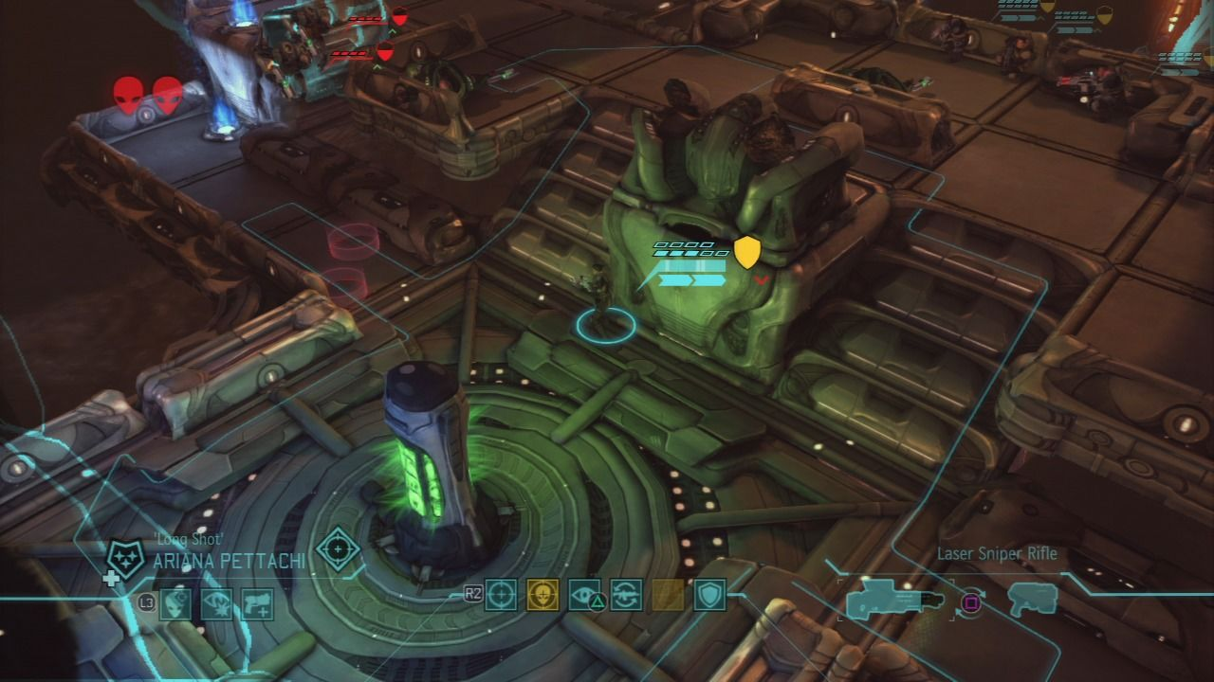

**Walls**: Uhh idk, you decide.

**Objective**: Defeat enemies(?)

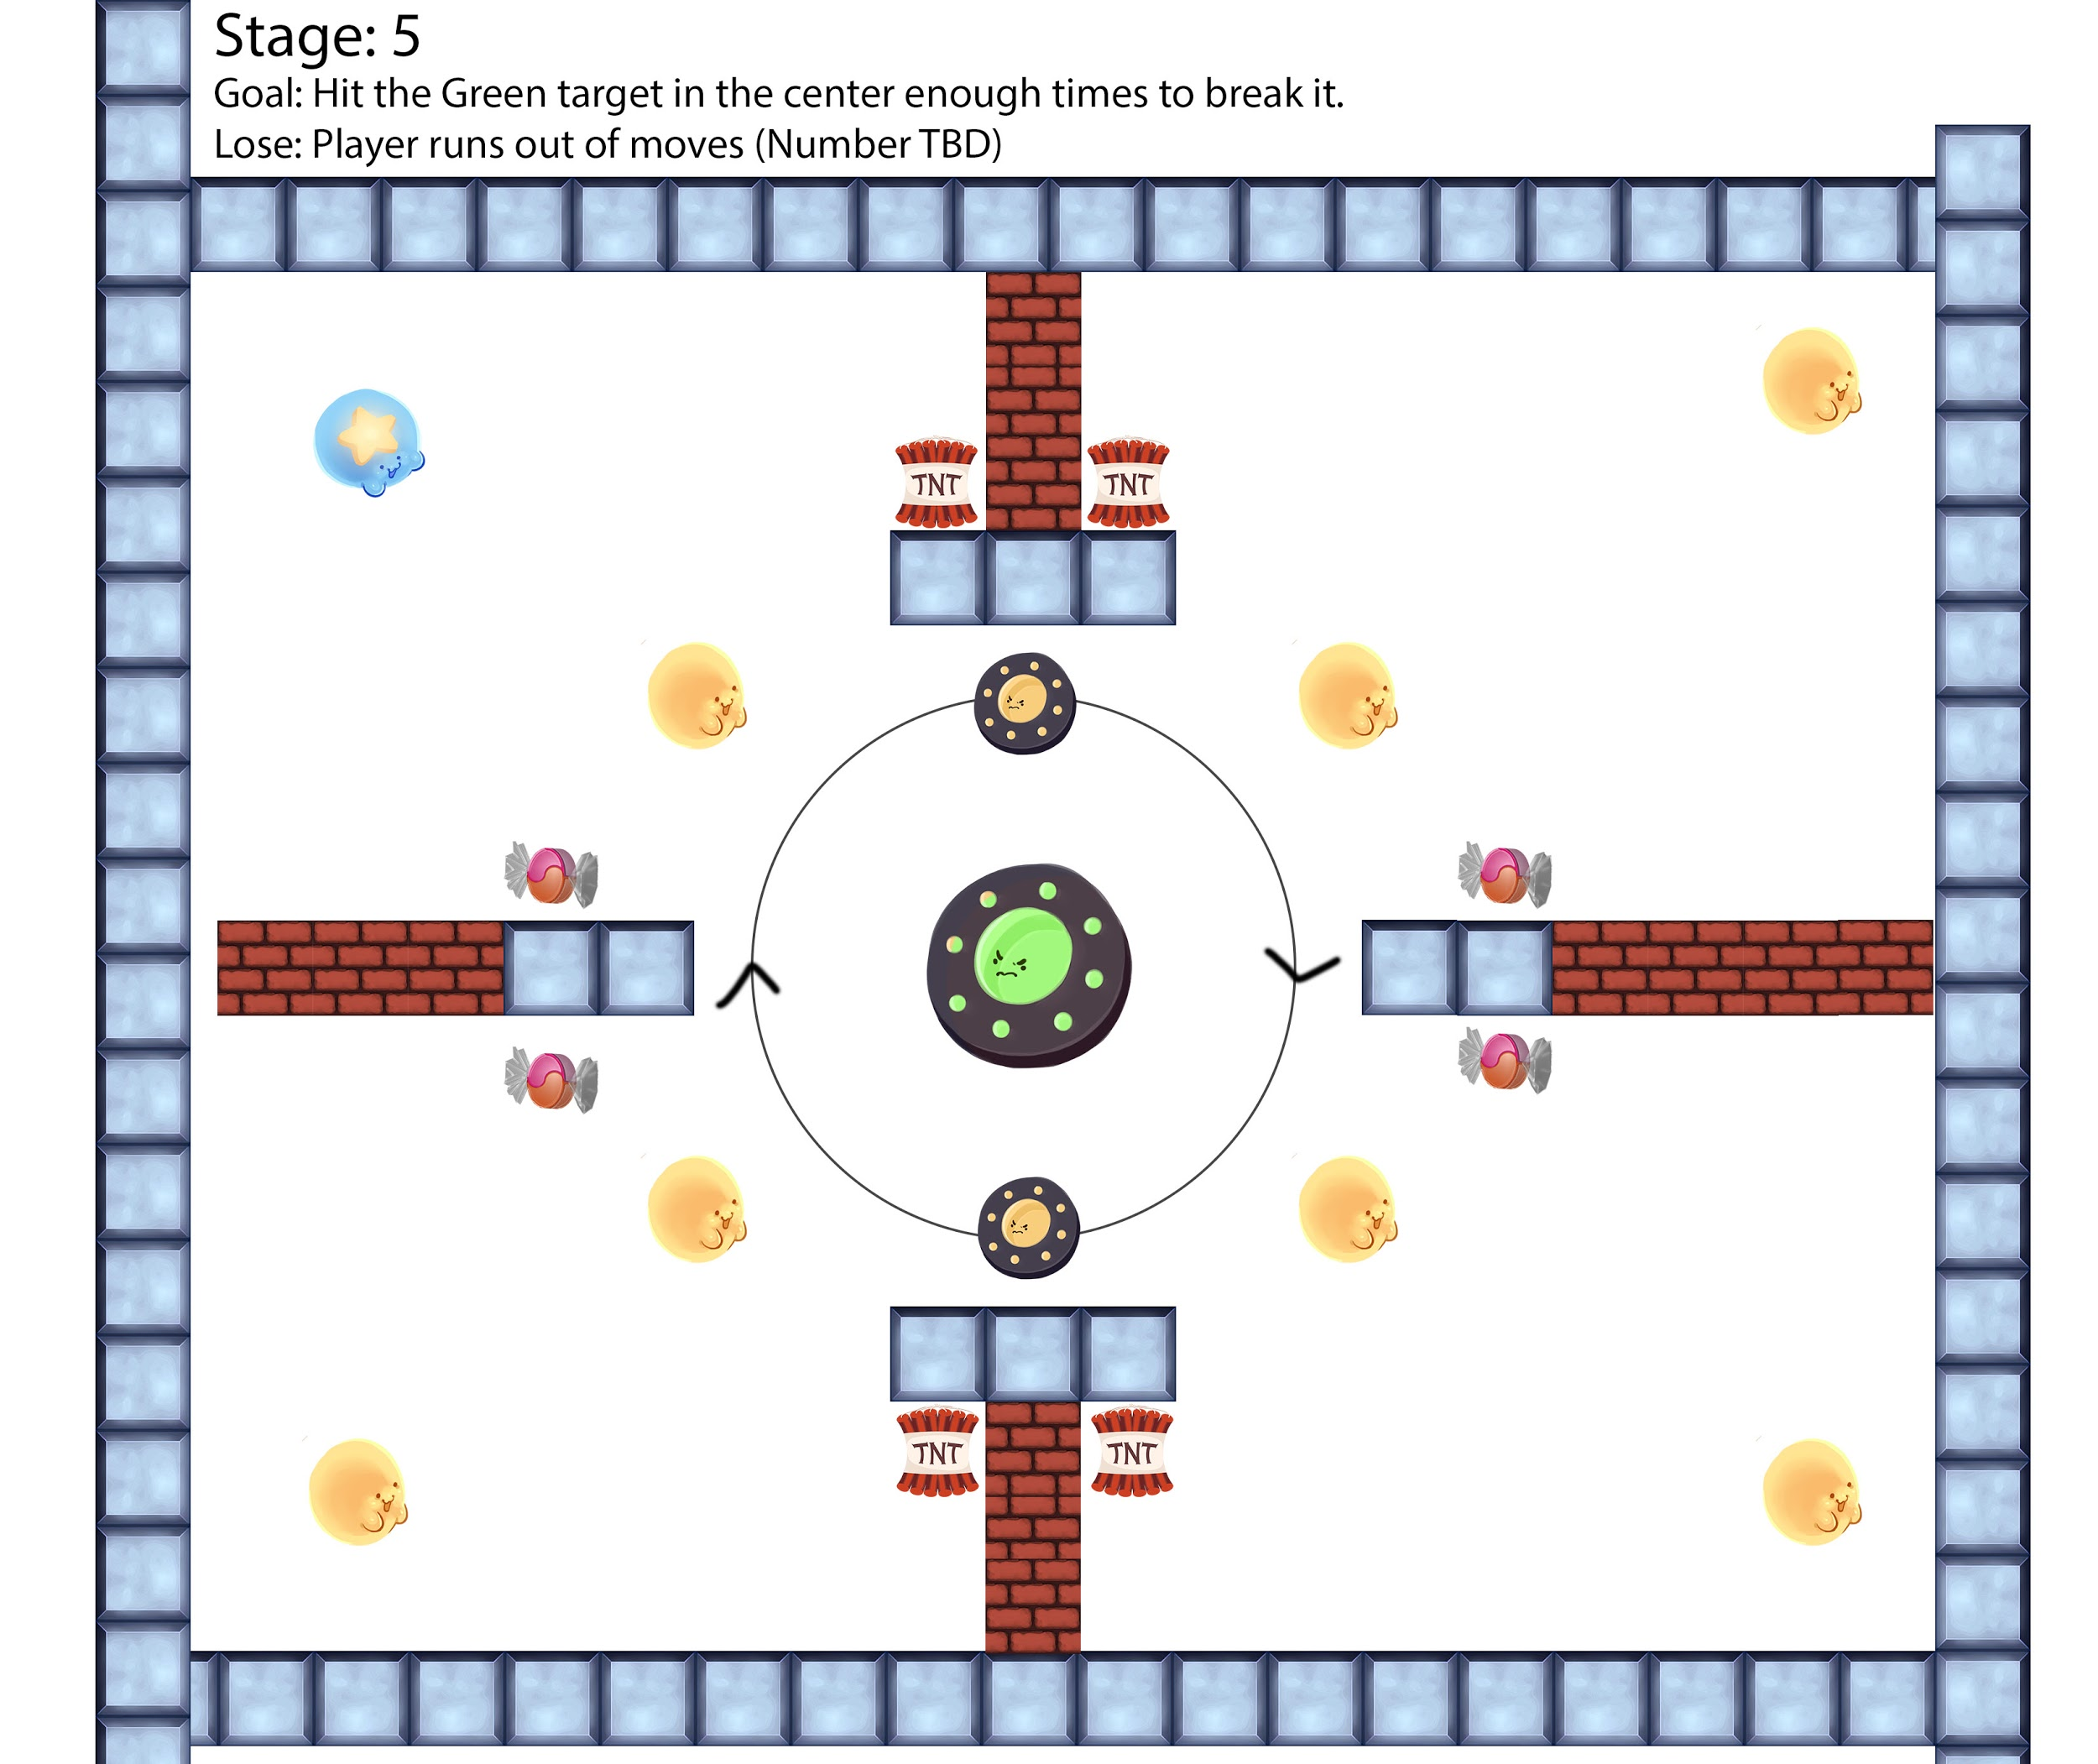

The mothership crashes to the ground and explodes, sending the Cuties out flying and laughing with glee. The Star Cutie is recognized as a Hero and all is well. The End…  
…  
Or is it?

A portion of the crashed mothership extends out a radio dish and begins *transmitting* a message...

Stage 6:

Memes